**WEEK-6**

**REACT**

**Exercise -1:To create a React Application with the name of “myfirstreact”**

npm install -g create-react-app

npx create-react-app myfirstreact

cd myfirstreact

**App.js;**

import React from ‘react’;

function App() {

return (

<div>

<h1>Welcome to the first session of React</h1>

</div>

);

}

export default App;

**OUTPUT**:

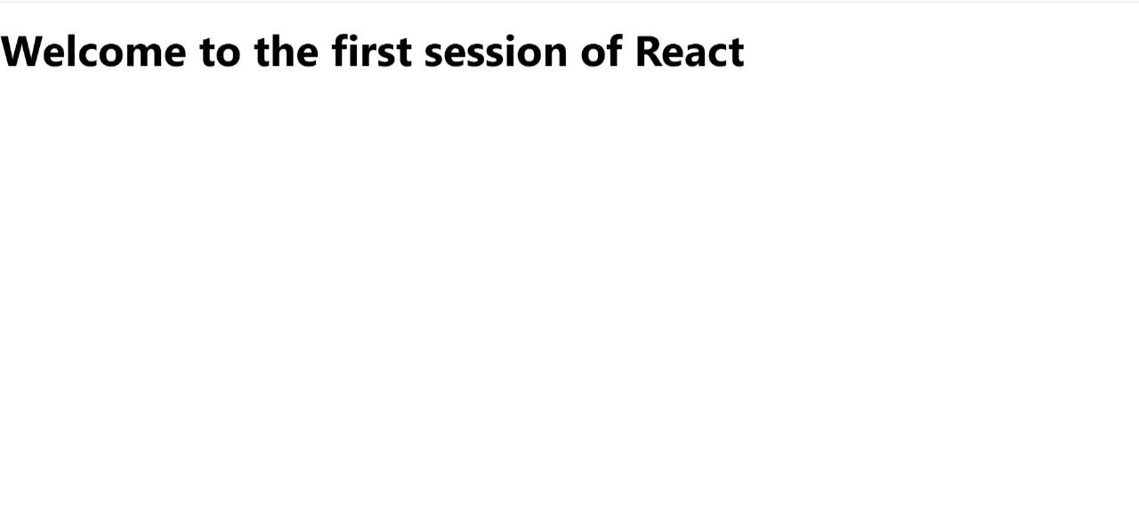

**Exercise -2: Create a react app for Student Management Portal named StudentApp**

npx create-react-app StudentApp

**Home.js:**

import React from ‘react’;

function Home() {

return (

<div>

<h2>Welcome to the Home page of Student Management Portal</h2>

</div>

);

}

export default Home;

**About.js:**

import React from ‘react’;

function About() {

return (

<div>

<h2>Welcome to the About page of the Student Management Portal</h2>

</div>

);

}

Export default About;

**Contact.js:**

import React from ‘react’;

function Contact() {

return (

<div>

<h2>Welcome to the Contact page of the Student Management Portal</h2>

</div>

);

}

export default Contact;

**App.js:**

import React from ‘react’;

import Home from ‘./Components/Home’;

import About from ‘./Components/About’;

import Contact from ‘./Components/Contact’;

function App() {

return (

<div className=”App”>

<Home />

<About />

<Contact />

</div>

);

}

export default App;

OUTPUT:

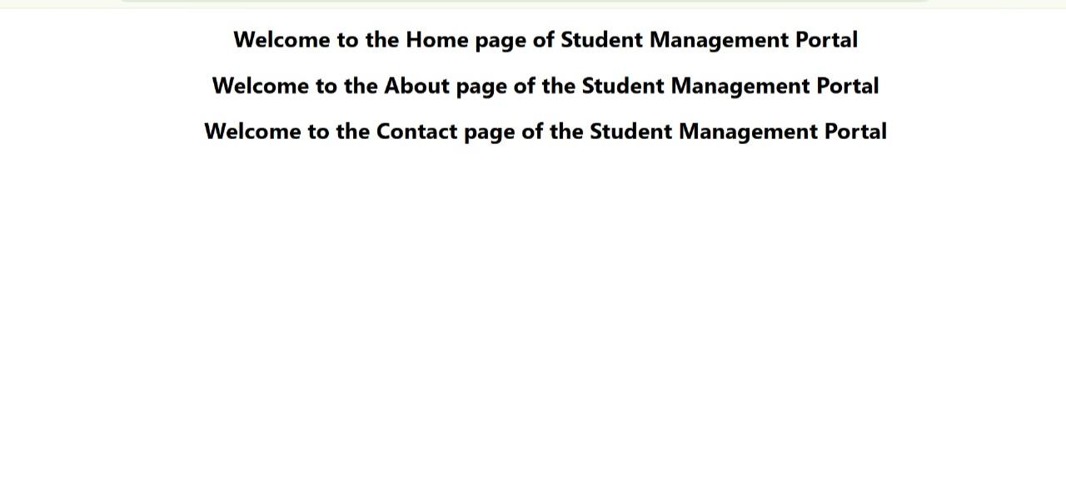

**Exercise -3:Create a react app for Student Management Portal named scorecalculatorapp**

npx creat-react-app scorecalculatorapp

cd scorecalculatorapp

**CalculateScore.js:**

import ‘./Stylesheets/mystyle.css’;

const percentToDecimal = (decimal) => {

return (decimal.toFixed(2) + ‘%’);

};

const calcScore = (total, goal) => {

return percentToDecimal(total / goal);

};

const CalculateScore = (props) => {

return (

<div className=”score-container”>

<h2>Student Score Calculator</h2>

<p><strong>Name:</strong> {props.name}</p>

<p><strong>School:</strong> {props.school}</p>

<p><strong>Total Marks:</strong> {props.total}</p>

<p><strong>Goal Marks:</strong> {props.goal}</p>

</div>

);

};

export default CalculateScore;

**mystyle.css:**

.Name

{

font-weight:300;

color:blue;

}

.School

{

color:crimson;

}

.Total

{

color:darkmagenta;

}

.formatstyle

{

text-align:center,

font-size:large;

}

.Goal

{

color.forestgreen;

}

**App.js:**

import (CalculateScore) from ‘../src/components/CalculateScore’;

function App()

}

return(

<div>

<CalculateScore Name=”Steeve”]

School=(“DNV Public School”]

Total=(284)

Goal={3}

/>

</div>

export default App;

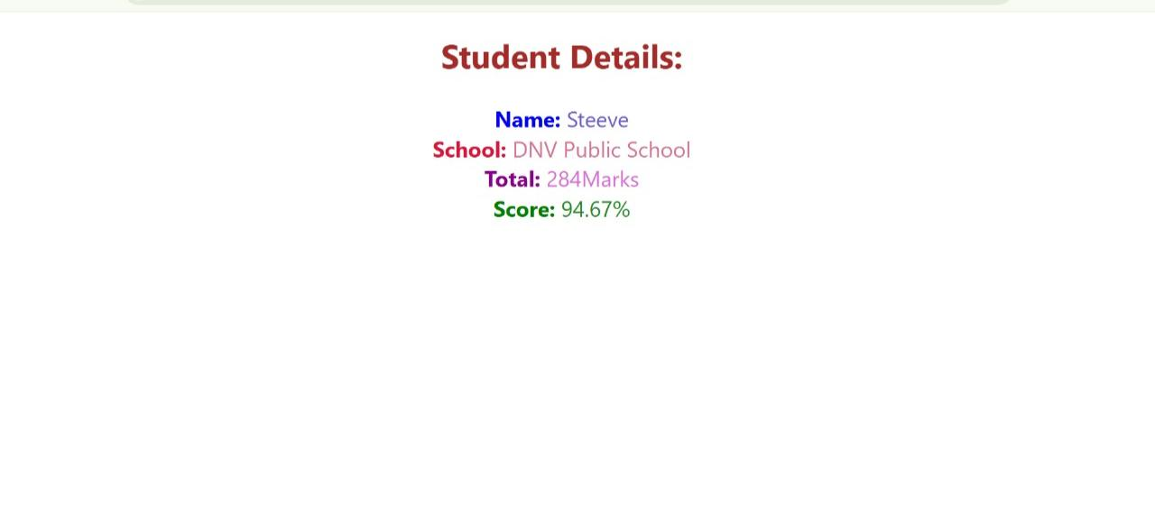OUTPUT:

**Exercise -4: Creating Blogapp**

npx creat-react-app blogapp

cd blogapp

**Post.js:**

import React from ‘react’;

class Post extends React.Component {

render() {

return (

<div>

<h2>{this.props.title}</h2>

<p>{this.props.body}</p>

</div>

);

}

}

export default Post;

**Posts.js:**

import React from ‘react’;

import Post from ‘./Post’;

class Posts extends React.Component {

constructor(props) {

super(props);

this.state = {

Posts: [],

Error: null

};

}

loadPosts() {

fetch(‘https://jsonplaceholder.typicode.com/posts’)

.then(response => response.json())

.then(data => this.setState({ posts: data }))

.catch(error => this.setState({ error }));

}

componentDidMount() {

this.loadPosts();

}

componentDidCatch(error, info) {

alert(‘An error occurred: ‘ + error.toString());

}

render() {

return (

<div>

<h1>Blog Posts</h1>

{this.state.posts.map(post => (

<Post key={post.id} title={post.title} body={post.body} />

))}

</div>

);

}

}

export default Posts;

**App.js:**

import React from ‘react’;

import Posts from ‘./Posts’;

function App() {

return (

<div className=”App”>

<Posts />

</div>

);

}

export default App;

OUTPUT:

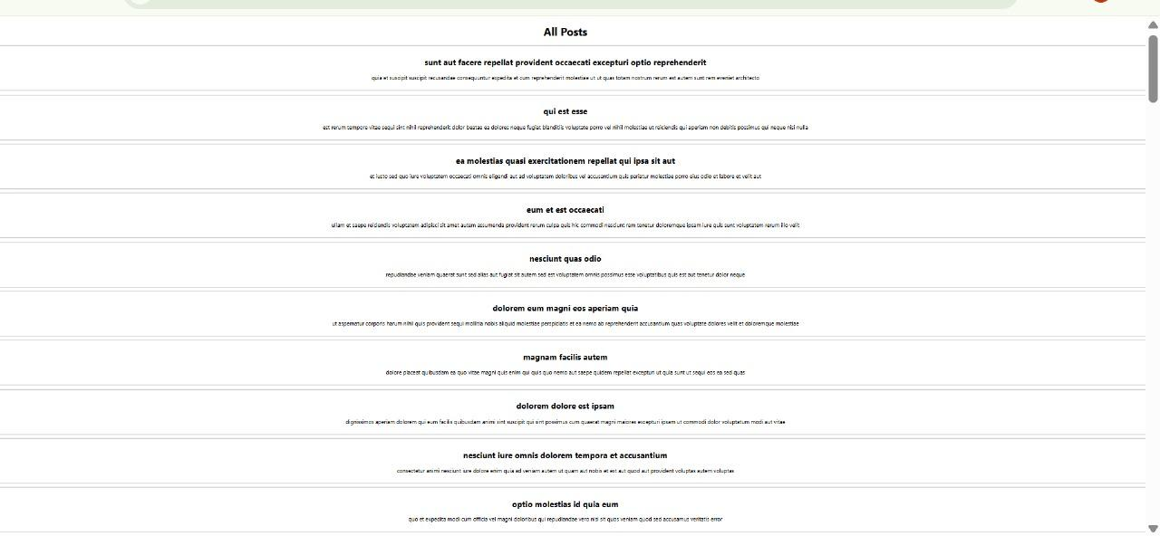

**Exercise -5: Cohort- dashboard**

**App.js:**

import React from ‘react’;

import CohortDetails from ‘./CohortDetails’;

function App() {

return (

<div style={{ padding: ‘20px’ }}>

<h2>Cohorts Details</h2>

<CohortDetails

Name=”INTADMDF10 -.NET FSD”

startDate=”22-Feb-2022”

status=”Scheduled”

coach=”Aathma”

trainer=”Jojo Jose”

/>

<CohortDetails

Name=”ADM21JF014 – Java FSD”

startDate=”10-Sep-2021”

status=”Ongoing”

coach=”Apoorp”

trainer=”Elisa Smith”

/>

<CohortDetails

Name=”CDBJF21025 – Java FSD”

startDate=”24-Dec-2021”

status=”Ongoing”

coach=”Aathma”

trainer=”John Doe”

/>

</div>

);

}

export default App;

**CohortDetails.js:**

import React from ‘react’;

import styles from ‘./CohortDetails.module.css’;

function CohortDetails(props) {

const { name, startDate, status, coach, trainer } = props;

const headingStyle = {

Color: status === ‘Ongoing’ ? ‘green’ : ‘blue’

};

return (

<div className={styles.box}>

<h3 style={headingStyle}>{name}</h3>

<dl>

<dt>Started On</dt>

<dd>{startDate}</dd>

<dt>Current Status</dt>

<dd>{status}</dd>

<dt>Coach</dt>

<dd>{coach}</dd>

<dt>Trainer</dt>

<dd>{trainer}</dd>

</dl>

</div>

);

}

export default CohortDetails;

**CohortDetails.module.js:**

.box {

width: 300px;

display: inline-block;

margin: 10px;

padding: 10px 20px;

border: 1px solid black;

border-radius: 10px;

vertical-align: top;

}

dt {

font-weight: 500;

}

OUTPUT:

